**System requirement specification**

**Web Chat system**

**TABLE OF CONTENT:**

|  |  |
| --- | --- |
| INDEX | PAGENO. |
| 1. INTRODUCTION   * PURPOSE OF DOCUMENT * SCOPE * OVERVIEW | **2** |
| 2.GENERAL DISCRIPTION |  |
| 3.REQUIREMENTS   * INTERFACE * HARDWARE * SOFTWARE |  |
| 4.SYSTEM DISCRIPTION   * FLOW * SYSTEM DESIGN * USECASEDISCRIPTION |  |
|  |  |
|  |  |
|  |  |

**1. Introduction:**

**Purpose of document:**

The evolution of the internet technologies had benefit people to accessing to the web

easily. More and more services provide by this internet All of this can be virtualize thank

to the technologies. Communication between people using the internet becomes part of

their daily life. People used to communicate with each other’s using the online chat

system to transfer their messages. Traditionally, when people need to communicate with

others they will have a face to face conversation to deliver the message, same goes to the

education field. It is strongly encourage that student seeking for academic assistance from

the lecturer when they face difficulties. Most often happening is when the exam are in the

corner and or assignment due date. The traditional way to have a consultation is student

make an email appointment with the lecturer and the lecturer accepted the appointment or

lecturer is free and available at his room or lecturer consultation hour. However, this

communication solution might be not convenient and not efficient due to some issue that

happen before the consultation started. The consultation session can be realized in

another similar way using an online solution.

There are few issue might be arise when the student want to have consultation with the

lecturer using the traditional method which is making appointment and meet at a lecturer

room to having the communication.

**1. Student or lecturer are not available in the school**

Sometime, the lecturer and student might have some personal issue and cannot

come to school. For example the lecturer has to outstation for some important

works and the outstation will take a period of time. Also student cannot come to

school because they are not available in the area that near to the school. During

this period of time, if a student wanted to have a consultation session with their

teacher, they cannot meet the respective teacher in the university which causes the

student delay their studies progress.

**2. Bunch of email have to filter**

Most often lecturer mailbox will be full of emails. Lecturer have to manually filter

out which emails is regarding the consultation requests. It will require the lecturer

efforts in filtering the emails. In the filtering process, lecturer might be missed

out the emails regarding the consultation.

**3. Queue issue regarding the appointment**

Sometime human error can be easily made by the lecturer when scheduled the

consultation session. The lecturer need to be extremely caution when scheduled

the consultation session. It is possible lecturer forget and scheduled two

consultation session at the same time. If it is happen, two students will came at the

same time. Based on first come first serve, the second student has to wait for the

first student to finish his consultation session then finally his turn. It is possible

the second student have to wait for a longer time if the first student requires lot of

times with the lecturer.

**4. Fail to recall about the consultation**

It is human nature that forgets some stuff from time to time. It is possible that

either student or lecturer have totally forgotten about the consultation. If it is

happen, these will caused another parties to wasting time and wait. Besides that, it

is possible that either student or lecturer have forgotten what is the context or

topic will be discuss in the later appointment. This is because student or lecturer

has totally forgotten about there will be a consultation session later.

**Therefore, the above issue can be enhanced using an online consultation solution.**

**Scope:**

This project will be developed in web based. The project is planned to introduce an online web chat system solution for the student and lecturer. The project included an appointment system that will be handling all the appointment between the student and the teacher effectively. Furthermore, a real time communication chat system will be included as the feature in the project to make a face to face communication channel between the student and the teacher. There are additional feature included in the project such as the screen sharing that share the current screen of the user, file sharing and text chat. Besides that, a SMS reminder system will be developed to inform the student or teacher about they will having the consultation session later. However, the real time communication web application will not be cover on the mobile site.

**Overview:**

This project aim to build an online chat system that has the capability to have real-time

communication using web browser. Our approach will be implemented for achieve

this real time communication. ourapproach does not require any additional plug in

to the browser with the constraint that the browser support we approach such as

Google Chrome. However the screens sharing in the approach require install a

plugin.

**1. To provide an online consultation solution**

The traditional way to have consultation might face some issues such as availability

of the student and lecturer in the school. Furthermore, if the student need to show

their work on their computer they can show in here because some student might only

have a desktop not a laptop it is not convenient to bring the entire desktop to the

school. Although external hard drive can be used to store and show the work in the

teacher computer but what if the work require some specific software to be open that

why it is not convenient. Therefore, an alternative online solution is proposed to help

to resolve some issue such as the location issue and making the consultation more

convenient.

**2. To provide a more systematic appointment system**

A systematic appointment system will help in manage the appointment more effective

and efficient. This appointment system is convenient because a template is provided

to completed and sent. Both student and teacher can check the appointment template

including checking the status of the appointment whether is accepted, rejected or

pending. If the current timeslot already book by another student, the appointment

made will not be successful. This also will minimize the lecturer effort to filter email

regarding the consultation in their mailbox. Therefore, a systematic appointment

system will help to reduce the effort in managing the appointments.

**3. To provide a SMS reminder to remind the lecturer about the consultation**

A SMS reminder will be sent to both parties, lecturer and student to remind them

about they will going to have a consultation later. This will ensure that both parties

will not miss out the appointments that have been made before. If student or lecturer

have forgotten about their appointment, when the SMS reminder come to their phone,

he can login into the system and check what is the discussion will be having later in

the consultation session. This also gives sometimes for the teacher and student in

preparation of the material that need to be discuss in the consultation session later.

Therefore, a SMS reminder system will help to increase the punctuality for the

consultation.

**General description:**

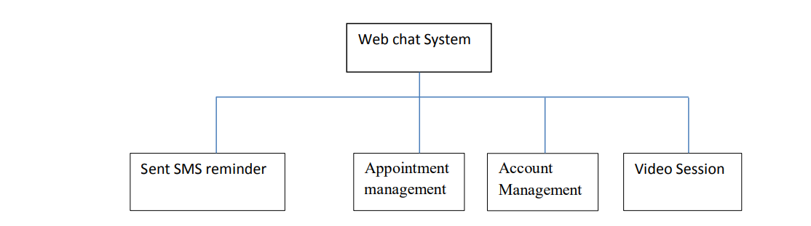**Appointment management**

The system enable user to make an appointment. If the user is a student, he or she only

able to make an appointment with the lecturer. In similar way, if the user is a lecturer, he

or she only able to make the appointment with the student. Furthermore, the user can

view the detail and time for the appointment. Besides that, the user able to delete the

appointment that has been made previously. Moreover, the user also able to accept or

decline the appointment that has been requested. Next, the user also can view the

appointment that have been rejected and delete the appointment.

**Sent SMS reminder**

The system will automatically schedule an SMS after the appointment have been accepted by the user. The system will sent the SMS reminder to remind the both student and lecturer that a consultation session will be held later.

**Video Session**

The system enabled the user to have a video conferencing and text chat with another user.

Moreover, the system also allowed the user to share his current computer screen with

another user. Next, the system also allowed the user to share the file with another user.

**Account Management**

The system allowed the user to register and create an account to login into the system. If

the user wanted to edit the information of the account, the system allowed the user update

the account information. The systems also enabled the user the change the old password

to a new password but the user must able to enter the old password correctly for the

confirmation.

**REQUIREMENTS:**

**Interface:**

* This application interacts with the user through G.U.I. The interface is

simple , easy to handle and self-explanatory.

* Once opened, user will easily come into the flow with the application and

easily uses all interfaces properly.

* However the basic interface available in our application is
* Title panel
* Content panel
* Admin panel.

**Hardware :**

Minimum requirements will be as follows:

* 128 MB RAM required.
* Processor with speed of 500 MHz.
* Internet or LAN connection.
* MOUSE: 2 or 3 button mouse
* KEYBOARD: 101 key Keyboard

**Software :**

* Notepad++ is a text editor and source code editor and provides an

environment for developing HTML, jsp, JavaScript many other editing

purposes.

* Coding done in java so required JDK 1.4 and above for run java programs.
* Operating system (such as window 7, 8, xp, Linux etc).

**System description:**

**Flow:**

**1. Register**

A new user has to register an account in order to use the chat system. Some particular

that user have to fill in such as the Username, password, first name, last name, select

the gender and role, email. The Username register for the system must be unique.

After register it will direct to the login page.

**2. Login**

The user has to fill in the username and the password in order to login to the system.

If the username or password is incorrect, the system will inform the user the incorrect

input and request user to type in again.

**3. Manage Account**

After successfully login into the system, the first page occur is the profile page of the

user. The user can chose to edit their account information such as changing the

password or update others detail into the system.

**4. View TimeTable**

User can view all the upcoming consultation session that have been approved.

**5. Manage Appointment**

The user can check their appointment here. There are table that show the sent

appointment, the pending appointment, accepted appoint and rejected appointment.

User can chose to delete the appointment that have been made and haven’t been

approved. User can accept appointment or reject appointment that been requested.

User can delete the appointment that have been rejected.

**6. Make appointment**

User can chose to make an appointment by filling the template provided. Some

criteria have to full in are the data, time, appointment receiver, and the remarks is

optional. After full in the template, the appointment can be sent.

**7. Video session**

User can have a video session. Some additional features such as screen sharing

feature, text chat and file sharing to benefit the student have understanding toward the problem.

**8. Logout**

User can choose to logout from the system.

**System design :**

Use case:

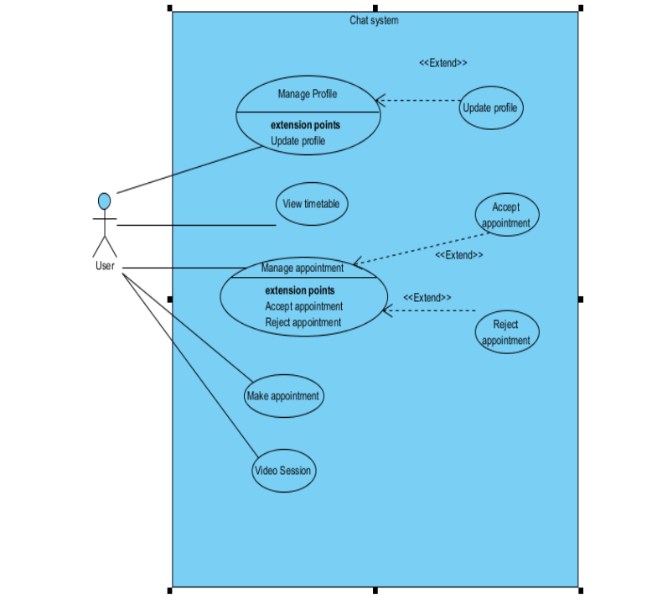

**Use Case Description**

|  |  |  |  |  |
| --- | --- | --- | --- | --- |
| **Use case ID** | UC001 | | **Version** | 1.0 |
| **Feature** | Manage user profile | | | |
| **Purpose** | To enable user to manage the user profile | | | |
| **Actor** | User | | | |
| **Trigger** | User press on the account information tab in the menu or user just  login into the system | | | |
| **Precondition** | The user must login into the system | | | |
| **Scenario Name** | **Step** | **Action** | | |
| **Main Flow** | 1 | The user click on the account information tab in the menu. | | |
| 2 | The system will show the user about the user information. | | |
| 3 | User click on the change password button to change  password. | | |
| 4 | User can change any field except the username which is not  editable. | | |
| 5 | User click on update button to update the user account. | | |
| 6 | System verifies the all the input of the user information. | | |
| 7 | System will update the user account. | | |
| 8 | System will display the message to inform user that the user  account has been successfully updated. | | |
| **Alternate Flow- User wish to change a new password** | 3.1 | System will open a change password popup window. | | |
| 3.2 | User enter the old password. | | |
| 3.3 | User enter the new password | | |
| 3.4 | User re-enter the new password for confirmation. | | |
| 3.5 | User press submit to submit to update the password. | | |
| 3.5 | System will validate the old password. | | |
| 3.6 | System will validate the new password and confirmation  password. | | |
| 3.7 | System update the new password display change password  successfully. | | |

|  |  |  |
| --- | --- | --- |
|  | 3.8 | System will close the popup and return to account  information page. |
| **Alternate Flow-**  **Invalid old password** | 3.5.1 | User enter the password not same with the old password. |
| 3.5.2 | System will display the entered password not same with the  old password. |
| **Alternative Flow-**  **New password not same with the confirmation**  **password** | 3.6.1 | User enter the confirmation password that not similar to the  new password. |
| 3.6.2 | System will display the new password and confirmation password not same. |
| **Rules** | User must login into the system | |

|  |  |  |  |  |
| --- | --- | --- | --- | --- |
| **Use case ID** | UC002 | | **Version** | 1.0 |
| **Feature** | User can view the timetable | | | |
| **Purpose** | To enable user to view the timetable for the consultation session. | | | |
| **Actor** | User | | | |
| **Trigger** | User click on the timetable tab in the menu. | | | |
| **Precondition** | User must login into the system. | | | |
| **Scenario Name** | **Step** | **Action** | | |
| **Main Flow** | 1 | User click on the timetable tab in the menu. | | |
| 2 | The system will show the user about the detail of the  upcoming appointment. | | |
| **Rules** | User must login into the system. | | | |
|  |  | | | |

|  |  |  |  |
| --- | --- | --- | --- |
| **Use case ID** | UC003 | **Version** | 1.0 |
| **Feature** | Manage appointment | | |

|  |  |  |
| --- | --- | --- |
| **Purpose** | To enable user to manage the appointments | |
| **Actor** | User | |
| **Trigger** | User click on the appointmentlist tab in the menu. | |
| **Precondition** | The user must login into the system. | |
| **Scenario Name** | **Step** | **Action** |
| **Main Flow** | 1 | The user click on the appointmentlist tab in the menu. |
| 2 | System will show 3 panels to the user which is pending request,  pending reply and rejected appointment. |
| 3 | User click on the pending request panel. |
| 4 | User click on the pending reply panel. |
| 5 | User click on the Rejected panel. |
| **Alternate Flow- User click on the pending request panel** | 3.1 | System will display the pending requested |
| 3.2 | User delete the appointment |
| 3.3 | The system delete the appointment requested. |
| 3.4 | System will display successfully deleted message. |
| **Alternate Flow- User click on the pending reply**  **panel** | 4.1 | System will display the appointment that has been requested. |
| 4.2 | System will prompt user either accept or reject the appointment requested. |
| **Alternate Flow- User accepted the appointment** | 4.2.1.1 | User press accept button to accept the appointment. |
| 4.2.1.2 | System will update the appointment status as accepted. |
| 4.2.1.3 | System will schedule a SMS reminder to be sent later. |
| 4.2.1.4 | System will generate a video session link to be used as  consultation later. |
| **Alternate Flow-**  **User rejected the appointment** | 4.2.2.1 | User press reject button to reject the appointment. |
| 4.2.2.2 | System will update the appointment status as rejected |
| **Alternate Flow-**  **User click on the rejected panel** | 5.1 | System will display the rejected appointment to the user. |
| 5.2 | User can delete the appointment that have been rejected. |

|  |  |
| --- | --- |
| **Rules** | The user must login into the system. |

|  |  |  |  |  |
| --- | --- | --- | --- | --- |
| **Use case ID** | UC004 | | **Version** | 1.0 |
| **Feature** | Make appointment | | | |
| **Purpose** | To enable user to make appointment | | | |
| **Actor** | User | | | |
| **Trigger** | User click on the make appointment tab in the menu. | | | |
| **Precondition** | The user must login into the system. | | | |
| **Scenario Name** | **Step** | **Action** | | |
| **Main Flow** | 1 | The user click on the makeappointment tab in the menu. | | |
| 2 | System will display an appointment template for the user to  fill in. | | |
| 3 | System will display a list of user. | | |
| 4 | User need to fill in all the appointment detail in the template. | | |
| 5 | User submit the appointment template | | |
| 6 | System will verify the input of the user. | | |
| 7 | System will display appointment successfully made. | | |
| **Alternate Flow-**  **User is a student** | 3.1 | System will only display the lecturer option. | | |
| **Alternate Flow-**  **User is a student** | 3.2 | System will only display the Student option. | | |
| **Alternate Flow- The time table**  **clashing** | 7.1 | The input and the timetable of either the user or the  appointment user have been clash. | | |
| 7.2 | System display the appointment made not successfully. | | |
| **Rules** | The user must login into the system. | | | |

|  |  |  |  |
| --- | --- | --- | --- |
| **Use case ID** | UC005 | **Version** | 1.0 |

|  |  |  |
| --- | --- | --- |
| **Feature** | Video session | |
| **Purpose** | To enable user to have online conferencing. | |
| **Actor** | User | |
| **Trigger** | User click on the video session tab in the menu. | |
| **Precondition** | The user must login into the system. | |
| **Scenario Name** | **Step** | **Action** |
| **Main Flow** | 1 | The user click on the video session tab in the menu. |
| 2 | The system will show the video session that are available. |
| 3 | The user must click on the ready button to inform another  user that he or she is available. |
| 4 | System enabled the start button to start the video session. |
| 5 | User click on the start button. |
| 6 | System will open a new popup for the video session. |
| 7 | User can start the video session but click the start button. |
| 8 | System prompts for the user video and audio input. |
| 9 | User enabled the audio and video input. |
| 10 | User click on the screen sharing button. |
| 11 | User click on the share file button. |
| 12 | User can click on the text chat to sent message. |
| **Alternate Flow- No audio or**  **video input** | 1.1 | User does not have an audio or video input device. |
| 1.2 | System will unable to start the session. |
| **Alternate Flow- No Screen**  **Sharing plug in** | 5.1 | User does not have the screen sharing plug in to share the  screen. |
| 5.2 | System will unable to start the screen sharing. |
| **Rules** | The user must login into the system. | |

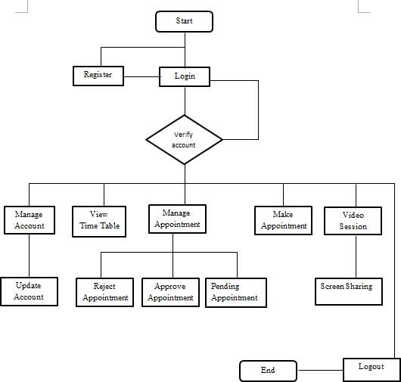**system flow:**

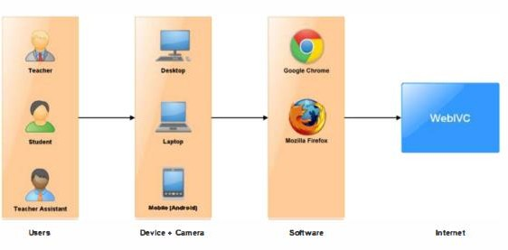 **Web-based interactive Virtual Classroom**

**Flow diagram**

**Functional analysis**

In this analysis phase, the requirement and functional of this project is defined. One of the requirements for the online chat system is have a video session to simulate face to face conversation. After analysis requirement, some features have to be added in order to fulfill the requirement. In order to fulfill the requirement, this chat system is introduced for to perform the video session along with some additional feature such as the screen sharing and the file sharing.

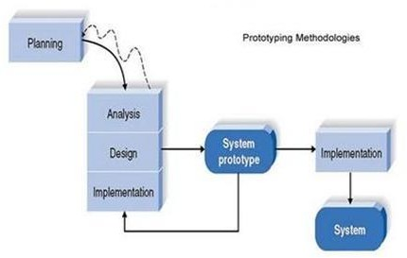

|  |  |
| --- | --- |
| **Design** | In the design phase, the system will be consult based on the requirement and the functional from the analysis phase. Some of the diagrams are deliver to illustrate the system such as the flow chart to show the system flow, the entity relationship diagram to show the database design, the architectural diagram to show the architectural design and the use-case diagram show what the user can do in the  system. |
|  |  |

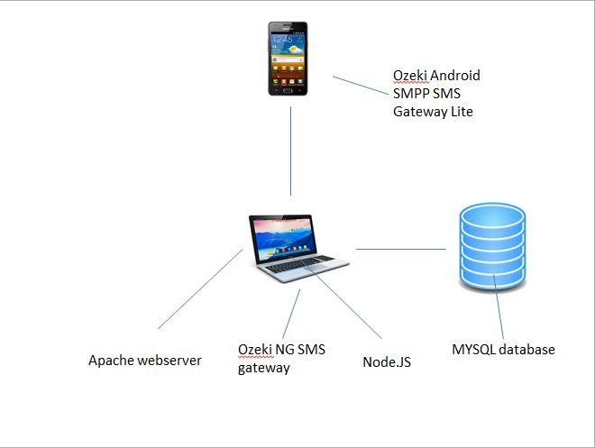**Architectural diagram:**

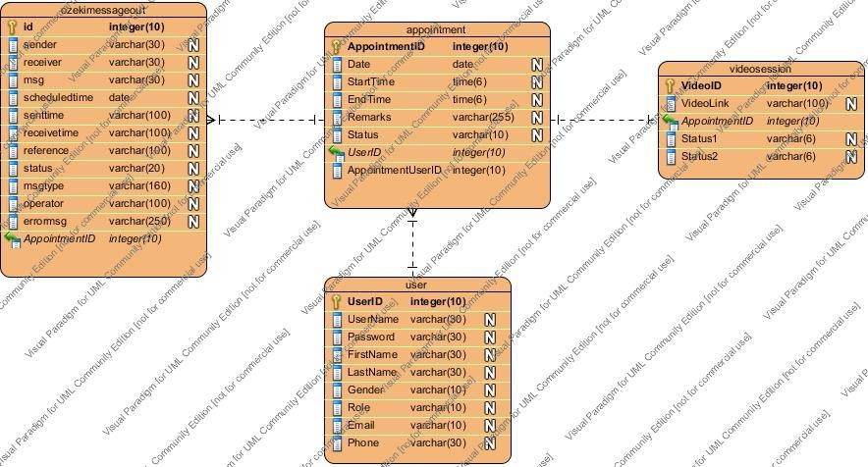**ENTITY RELATIONSHIP DIAGRAM:**

# Conclusion

**Project Review, Discussions and Conclusions:**

This project is talking about develop a chat system for the teacher and student. The motivation of develop this project is because the communication through internet become commonly in now daily life. Communication using internet in the academic field might help the student and teacher communicate more effective and efficient. The transitional consultation method may give several problems. The first problem is student or lecturer is not available in the school. With the online consultation solution, location is not a concern as long as have internet. Furthermore, if the student need to show their work on their computer they can show in here because some student might only have a desktop not a laptop it is not convenient to bring the entire desktop to the school. The second issue is bunches of email have to filter by the lecturer. A systematic appointment system will help in manage the appointment more effective and efficient. The student or teacher can manage their appointment easily using the appointment system. The third issue is arrangement issue regarding the appointment. Lecturer might mistakenly schedule the appointment. The appointment system will detect that if the time slot is available and ensure that no 2 consultation session is schedule at same time. If the timeslot either lecturer or student have clashing the appointment will not be made. The last issue is failed to recall about the consultation. It is human nature that forgets some stuff from time to time. SMS reminder system developed helped to remind the lecturer about the consultation session.